Linear regression analysis

|  |  |  |  |  |  |  |
| --- | --- | --- | --- | --- | --- | --- |
| **RECORD OF PRE, by TREATMENT** | |  | ***w/ outliers*** |  |  | ***w/out outliers*** |
|  |  | *R^2* | *Adjusted R^2* |  | *R^2* | *Adjusted R^2* |
|  | Conjunction Search, Target Absent | 52% | 50% |  | 66% | 64% |
|  | Conjunction Search, Target Present | 38% | 35% |  | 41% | 38% |
|  | Feature Search, Target Absent | 0% | -5% |  | 1% | -4% |
|  | Feature Search, Target Present | 8% | 4% |  | 13% | 8% |

ANOVA analysis

|  |  |  |  |
| --- | --- | --- | --- |
| **RECORD OF PRE, by CONSTRASTS** |  | ***R^2*** |  |
|  |  | ***w/ outliers*** | ***no outliers*** |
| Target Absent: Conjunction vs. Feature | | 69% | 80% |
| Target Present: Conjunction vs. Feature | | 62% | 71% |
| Conjuction: Target Absent vs. Target Present | | 24% | 35% |
| Feature: Target Absent vs. Target Present | | 4% | 12% |

ANCOVA analysis

|  |  |  |  |
| --- | --- | --- | --- |
| **RECORD of PRE, by CONSTRASTS** |  | **R^2** | |
|  |  | *w/ outliers* | *no outliers* |
| Target Absent: Conjunction vs. Feature | | 67% | 77% |
| Target Present: Conjunction vs. Feature | | 62% | 70% |
| Conjunction: Target Absent vs. Target Present | | 23% | 32% |
| Feature: Target Absent vs. Target Present | | 4% | 7% |

Linear Regression

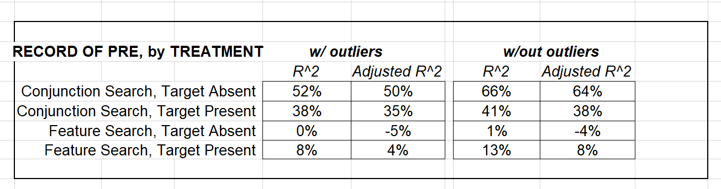

ANOVA

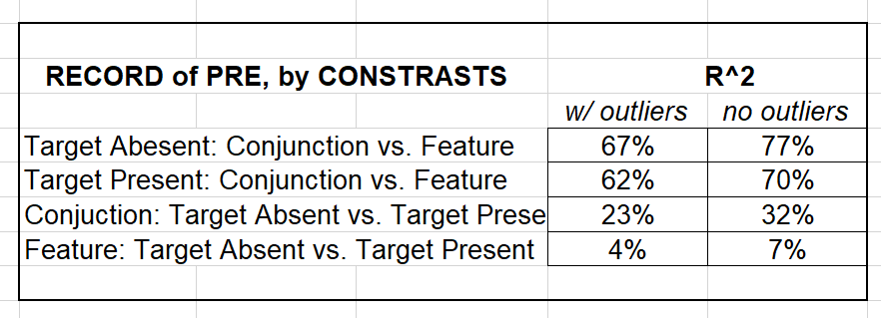

ANCOVA

